**DRIVER DROWSINESS DETECTION SYSTEM**

*Submitted by*

**Abhilash Maithani**

**Ankul Kumar**

**Rahul Lakhchaura**

**Ritesh Kumar**

*Under guidance of*

**Ms. Preeti Chaudhary**



**DEPARTMENT OF COMPUTER SCIENCE AND ENGINEERING**

**GRAPHIC ERA HILL UNIVERSITY**

**May 2023**

**CERTIFICATE**

This is to certify that the thesis titled **“Driver Drowsiness Detection System”** submitted by **Author**, to Graphic Era Hill University for the award of the degree of **Bachelor of Technology**, is a bona fide record of the research work done by him/her under our supervision. The contents of this project in full or in parts have not been submitted to any other Institute or University for the award of any degree or diploma.

**Preeti Chaudhary**

Project Guide

(Designation)

GEHU,Dehradun

Place: Dehradun

Date:

**ACKNOWLEDGEMENT**

We have made efforts in this project. However, it would not have been possible without the kind support and help of many individuals. We would like to extend our sincere thanks to all of them.

First, we are thankful to our project guide Ms. Preeti Chaudhary under whose guidelines we were able to progress in our project. We are wholeheartedly thankful to her for giving us her valuable time & attention & for providing us with a systematic way of progressing our project in time.

Then we are thankful to all members of this project, without their support and handwork are this could never have been possible to make any progress in this project.

**Abhilash Maithani** (1918115)

**Ankul Kumar** (1918213)

**Rahul Lakhchaura** (1918580)

**Ritesh Kumar** (1918609)

**ABSTRACT**

Road safety is a major concern for public health as avoiding it can lead to injuries and fatalities. Driver drowsiness is a genuine issue that contributes to several auto accidents each year. The focus of this research is to make the utmost effort to detect drowsiness in drivers during real-life driving situations. The objective of developing driver drowsiness detection systems is to minimize the occurrence of road accidents caused by drowsy driving. The paper suggests a technique that uses visual information in real-time to oversee the tiredness/ fatigue of drivers. This paper presents an approach for facial feature extraction using the Dlib library in Python. The Dlib library is well-known in the fields of machine learning and computer vision and offers a range of pre-trained models that can detect facial landmarks. To detect 68 specific facial landmarks on an image of a face, the approach proposed in this paper makes use of Dlib's pre-trained shape predictor model. Further we use the eyes landmarks and SVM (Support vector machine) algorithm to determine EAR (Eye aspect Ratio). Next, we determine whether the eyes are open or closed, and then assess the level of fatigue based on the sequence of eye states. A technique for detecting driver fatigue based on vision is a natural, convenient, and non-intrusive method for monitoring a driver's alertness.

Keywords: Driver Drowsiness Detection, Dlib, EAR (Eye Aspect Ratio), SVM (Support Vector Machine), Eye Detection, Eye Tracking.

**TABLE OF CONTENTS**

Chapter/Title Page No.

Certificate 1

Acknowledgement 2

Abstract 3

List of tables 5

List of figures 5-6

1 **INTRODUCTION**

* 1. **OBJECTIVES 8**
  2. **SIGNIFICANCE OF THIS PROJECT 8**
  3. **MOTIVATION 8**

1. **BACKGROUND ANALYSIS**
   1. **Literature Survey 10**
2. **REQUIREMENT ANALYSIS**
   1. **System Requirements 13**
      1. **Functional Requirements 13**
      2. **Non-Functional Requirements 13**
   2. **System Design**
      1. **Use Case Diagram 14**
      2. **Class Diagram 15**
      3. **DFD 15**
3. **PROJECT DESIGN**
   1. **Flow chart 16**
   2. **Algorithms Used 17**
   3. **Libraries Used 20**
   4. **Configuration 20**
4. **IMPLEMENTATION 21**
5. **RESULT/TESTING OF PROJECT 23**
6. **CONCLUSION AND FUTURE SCOPE 26**

**APENDIX 28**

**REFERENCES 30**

**List of tables**

|  |  |  |
| --- | --- | --- |
| **S No.** | **Title** | **Page No.** |
| 1 | Literature Survey | 10 - 12 |
| 2 | RESULT/TESTING OF PROJECT | 25 |

**List of figures**

|  |  |  |
| --- | --- | --- |
| **S No.** | **Title** | **Page No.** |
| 1 | Use case diagram for driver drowsiness detection system | 14 |
| 2 | Class diagram for Driver Drowsiness Detection System | 15 |
| 3 | DFD for Driver Drowsiness Detection System | 15 |
| 4 | Flow chart of driver drowsiness detection system | 16 |
| 5 | Haar like features | 17 |
| 6 | 68 facial landmarks | 18 |
| 7 | Eye Aspect Ratio | 19 |
| 8 | Capturing the image through CV2 | 21 |
| 9 | Detected the ROI. | 21 |
| 10 | Eyes are closed and showing alert. | 22 |
| 11 | Capturing the image. | 23 |
| 12 | Straight face, Bad light, no glasses. | 23 |
| 13 | Straight face, good light, no glasses. | 23 |
| 14 | Straight face, Bad light, no glasses. | 23 |
| 15 | Straight face, good light, no glasses | 24 |
| 16 | Tilted face, Bad light, no glasses. | 24 |
| 17 | Tilted face, Bad light, no glasses. | 24 |
| 18 | Tilted face, good light, no glasses. | 24 |
| 19 | Tilted face, good light, no glasses. | 24 |

**CHAPTER-1**

**INTRODUCTION**

There are various causes for highway traffic accidents and one of the main factors is drowsy driving and driver fatigue. Driver fatigue and drowsiness are blamed for a huge portion of accidents, which are a major cause of injury and death globally. A survey conducted by the Central Road Research Institute (CRRI) on the 300-km Agra-Lucknow Expressway shows that fatigued drivers who fall asleep at the wheel cause 40% of traffic accidents. The study on sleepy drivers has highlighted the need for teaching highway commuters about the significance of taking regular breaks and getting enough sleep for safety in a nation where road accidents claim four lives every minute. There are several reasons why drivers may feel sleepy while driving, such as insufficient sleep, sleep-related health problems, certain medicines, alcohol, and other medical conditions. Even though attempts have been made to encourage safe driving practices, the high number of accidents caused by driver fatigue and drowsiness remains a significant issue for road safety. Here we suggested a project to create a real-time driver drowsiness detection system based on methods for sensing eyes to lessen the dangers related to driver inattention. The system will use measurements of the eye aspect ratio (EAR) to identify minute changes in the driver's facial characteristics, acting as an early notification system to prompt the driver to prevent collisions. The suggested device will have a dashboard-mounted camera that records the driver's face and transmits the footage to a computer for analysis. The video stream will be analyzed using deep learning algorithms to find the driver's eyes. To Detect drowsiness the system will detect signs such as brink rate, drooping eyelids, and slow eye movement by monitoring the eye movement of driver. The system suggested in the project will issue alerts to the driver in real-time when the level of driver drowsiness exceeds a predetermined threshold. Creating a reliable and accurate system for detecting driver drowsiness as proposed in the project can have a significant impact on improving road safety and reducing the frequency of accidents that occur due to driver fatigue and sleepiness.

* 1. **OBJECTIVES**
* To suggest different ways to detect driver fatigue.
* To create a system that can recognize sleepiness and exhaustion using the eyelids closing motions.
* To develop a drowsiness detection system that sounds an alarm/warning alert when it detects fatigue and drowsiness.
  1. **SIGNIFICANCE OF THIS PROJECT**

There are various causes for highway traffic accidents and one of the main factors is drowsy driving and driver fatigue. The main causes of road accidents in India are drowsiness and weariness. To minimize and decrease the frequency of accident caused due to driver drowsiness and fatigue we are introducing Driver drowsiness detection system. It detects the drowsiness signs and warn the driver with an alert alarm.

* 1. **MOTIVATION**

The incentive for a driving drowsiness project stems from the essential want to address the problem of driving when the driver is drained out, which is very dangerous for road safety. Drowsy driving refers to running a car in sleepiness which leads to impaired alertness, reduced reaction time, and compromised choice-making talents. This circumstance can bring about injuries, injuries, or even fatalities.

The goal of the research is to create a system that can recognize and warn drivers when they exhibit indicators of exhaustion or sleepiness. The system can track many characteristics including eye movements, head posture, and other behavioral indications to determine the driver's degree of attentiveness by utilizing cutting-edge technology like computer vision and machine learning.

Driver drowsiness is a critical safety difficulty that may result in injuries and fatalities on the street. The country wide dual carriageway visitor’s protection management (NHTSA) estimates that sleepy driving effects in 72,000 collisions, 44,000 injuries, and 800 fatalities annually inside the United States of America. And in India, according to a survey carried out through the significant avenue studies Institute (CRRI) on the three hundred-km Agra-Lucknow throughway, fatigued drivers who doze off on the wheel reason 40% of visitor’s injuries.

Given the high number of accidents and fatalities caused by drowsy driving, there may be a strong need for technologies that can help save you from these incidents. One method to addressing this hassle is to expand a system that could hit upon signs and symptoms of driver drowsiness and alert the driver or take motion to prevent a twist of fate. This kind of system may want to doubtlessly keep lives, reduce injuries, and save your belongings harm. It can also assist in reducing the expenses associated with injuries, such as clinical prices and insurance claims.

Overall, the primary motivation for the Driver Drowsiness project is to promote road safety, prevent accidents caused by drowsy driving, and create a safer driving environment for everyone on the roads.

**CHAPTER-2**

**BACKGROUND ANALYSIS**

* 1. **Literature Survey**

To create a real-time system for detecting driver tiredness, several prior studies on driver drowsiness detection can be used as references. This chapter consists of a detailed discussion of the research that was examined for the development of this project. A complete analysis of different methods and concepts of detecting malware in the computer system is carried out.

|  |  |  |  |  |
| --- | --- | --- | --- | --- |
| S No. | Author | Title | Source | Findings |
| 1 | Wanghua Deng, Ruoxue Wu | Real-Time Driver-Drowsiness Detection System Using Facial Features | IEEE Xplore | The given paper used a new detection method for facial based on 68 key points and the experimental results showed that DriCare achieved around 92% accuracy. |
| 2 | Mahek Jain, Bhavya Bhagerathi, Sowmyarani C N | Real-Time Driver Drowsiness Detection using Computer Vision | Research gate | In the given research they proposed EAR for yawn detection and the system gave of 96% accuracy. |
| 3 | Araceli Sanchis de Miguel, Elena Magán López, M. Paz Sesmero Lorente | Driver Drowsiness Detection by Applying Deep Learning Techniques to Sequences of Images | Research gate | The give paper uses the two methods, first one uses a recurrent and convolutional neural network, while the second one uses deep learning techniques to extract numeric features from images providing 60-65% accuracy, which are introduced into a fuzzy logic-based system afterwards which provide 93% accuracy. |
| 4 | Burcu Kır Savaş, Yaşar Beefily | Real Time Driver Fatigue Detection Based on SVM Algorithm | IEEE Xplore | Given paper proposed an SVM-based method for drowsiness detection; studies revealed that this method has an accuracy rate of up to 97.93%. |
| 5 | Madhav Tibrewal , Aayush Srivastava , Dr. R. Kayalvizhi | A Deep Learning Approach to Detect Driver Drowsiness | **INTERNATIONAL JOURNAL OF ENGINEERING RESEARCH & TECHNOLOGY (IJERT)** | The offered paper employs Dlib's 68-point facial landmarks to calculate the eye aspect ratio and the linear SVM for visual categorization of eyes as open or closed. which have an accuracy rate of 94%. |
| 6 | Varad Ingale , Varun Gujarathi , Vasundhara Iyer, Varun Patil , Atharv Vanjari, Yogeshwari Rathod | Driver Drowsiness Detection System | **INTERNATIONAL JOURNAL OF ENGINEERING RESEARCH & TECHNOLOGY (IJERT)** | Eye detection accuracy using Dlib was found to be 80.17% accurate on average, and drowsiness accuracy was found to be 78.50% accurate on average. |
| 7 | Shrut Shah | Driver Drowsiness Detection using Microservices and Convolutional Neural Network | **INTERNATIONAL JOURNAL OF ENGINEERING RESEARCH & TECHNOLOGY (IJERT)** | The given paper uses the Microservices and Convolutional Neural Network. Which provide 83.65% accuracy. |
| 8 | Harshit Verma, Amit Kumar, Gouri Shankar Mishra, Ujjwal deep, Pradeep Kumar Mishra, Parma Nand | DRIVER DROWSINESS DETECTION | Research gate | The given paper uses the Haar Cascade Classifier for object detection, CNN, and Haar Cascade with OpenCV. Which provide 98% accuracy on both the training and test datasets |
| 9 | Mustafa Kamel Gatea, Sadik Kamel Gharghan,  Adnan Hussein Ali | Deep learning neural network for driver drowsiness detection using eyes recognition | Research gate | The given paper uses the Deep Cascaded Convolutional Neural Network (DCCNN) which is practically implemented in Raspberry Pi microcontroller. Which provide the accuracy of 99%. |
| 10 | G Mahalakshmi , Sharan Kumar S , Kishok Kumar M , Gokul M, Balamurali S | Drowsiness Detection Mobile Vision Face API | **INTERNATIONAL JOURNAL OF ENGINEERING RESEARCH & TECHNOLOGY (IJERT)** | The given paper uses the Mobile vision Face API. Which provide the 90.8% accuracy |

**CHAPTER-3**

**REQUIREMENT ANALYSIS**

The aim and scope of the requirements analysis is the identification, analysis, documentation, and management of project requirements. The main goal of the requirements analysis is to guarantee that the product meets the needs and expectations of the customer. The process of requirements analysis starts with gathering the requirements and ends with documenting the requirements in a software requirements specification (SRS).

* 1. **System Requirements**

To minimize and decrease the frequency of accidents caused due to driver drowsiness and fatigue we are introducing Driver drowsiness detection.

* + 1. **Functional Requirements**
* The system should have the ability to detect driver drowsiness/fatigue.
* System should recognize sleepiness and exhaustion using the eyelids closing motions.
* The system should continuously evaluate drivers’ facial features over the course of a long trip.
* System should raise an alarm, warning on the dashboard screen when it detects drowsiness.
* The system should have a user-friendly interface for easy operation.
  + 1. **Non-Functional Requirements**
* The camera used for capturing drivers’ video should be of high resolution.
* The system should work even in low light conditions.
* The alarm should be of high volume to wake the driver up.
* The system should be reliable and available 24/7.
* The system should have a low false positive rate.
  1. **System Design**
     1. **Use Case Diagram**

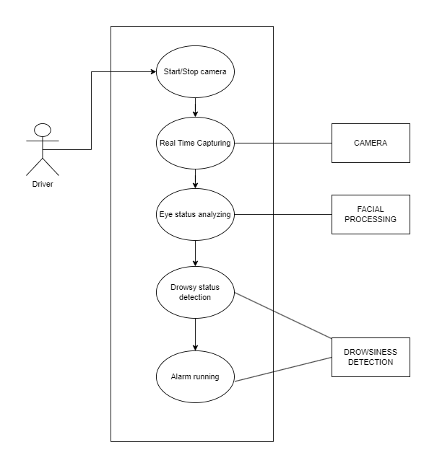

Figure 1: Use case diagram for driver drowsiness detection system

* + 1. **Class Diagram**

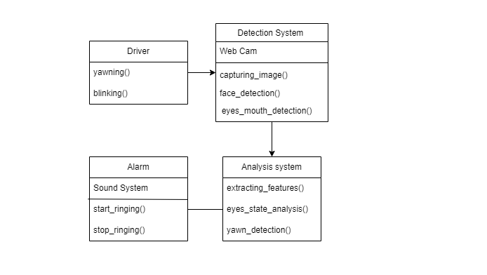

Figure 2: Class diagram for Driver Drowsiness Detection System

* + 1. **DFD**

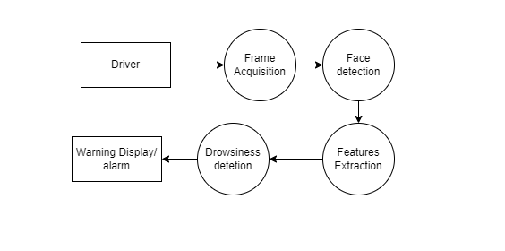

Figure 3: DFD for Driver Drowsiness Detection System

**CHAPTER-4**

**PROJECT DESIGN**

* 1. **Flow chart**

Figure 4: Flow chart of driver drowsiness detection system

* 1. **Algorithms Used**

A few algorithms and techniques have been used in the process of detecting face, eyes, and mouth, and to calculate EAR (Eye Aspect Ratio) for eye blink detection. The algorithm used for face detection is Haar Cascade, and for calculating EAR and detecting drowsiness is SVM (support vector machine).

Haar cascade Algorithm

For face detection we have used Haar cascade classifiers, Paul Viola, and Michael Jones in their 2001 publication "Rapid Object Detection using a Boosted Cascade of Simple Features" presented the efficient object recognition technique known as Haar feature-based cascade classifiers. Haar feature-based cascade classifiers is a machine learning based approach, here a lot of positive and negative images are used to train the cascade function which further is used to detect object in another image.

Positive image being the image of the object that we want our classifier to detect. And negative images are images of everything else.

Here we are working with face detection hence we need to train the cascade classifier with positive images (images of faces) and negative images (images without faces). After that, we must draw characteristics from it. The Haar characteristics in the picture below are utilized for this. Their convolutional kernel is exactly like ours. Each attribute is a single value that is derived via subtracting sum of pixels from the black rectangle under the white rectangle.

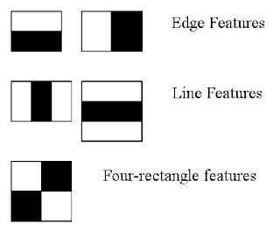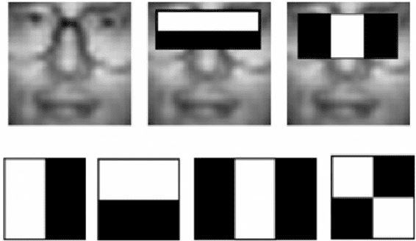

Figure 5: Haar like features

Facial Landmark Detection

As in the previous step we have used Haar cascade classifiers to detect face, now we need to detect ROI (Region of interest) i.e., eyes in the face image to move to next step of drowsiness detection, for this we have used Facial Landmark Detection for Eye Detection. Identifiable areas of the face are localized and represented using facial landmarks, such as:

* Eyes
* Mouth
* Nose
* Eyebrows
* Jawline

The Facial landmark detector we are using in the system is included in dlib library. The 68 (x, y)-coordinates that correspond to facial structures on the face are estimated using the pre-trained facial landmark detector included inside the dlib package.

The indexes of the 68 coordinates can be visualized on the image below:

The indexes of the 68 coordinates can be visualized on the image below: 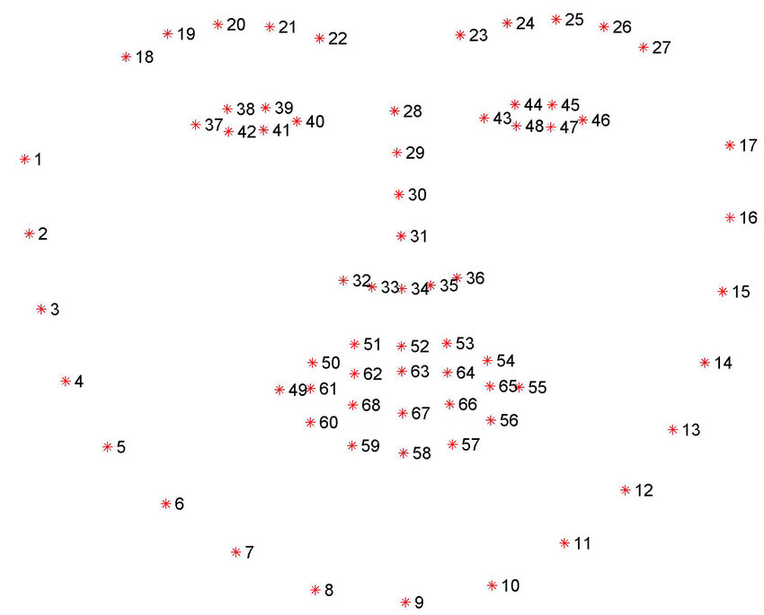

Figure 6: 68 facial landmarks

We can detect both eyes using the eyes landmarks:

* The right eye using [36, 42].
* The left eye with [42, 48]

SVM (Support Vector Machine)

Next Step in the algorithm is Recognition of eyes state. For this we propose a simple and efficient algorithm SVM (Support Vector Machine) here we will take the eyes landmarks that we have detected in previous stage and use them to detect eyes blink. The landmarks are used to produce a single scalar variable EAR (Eye aspect ratio) that represents the level of the eye opening.

Eye Aspected Ratio Calculation:

For every video frame, the eye landmarks are detected. The eye aspect ratio (EAR) between

height and width of the eye is computed.

EAR = ( ||p2 − p6|| + ||p3 − p5|| ) / 2* ||p1 − p4|| (1)

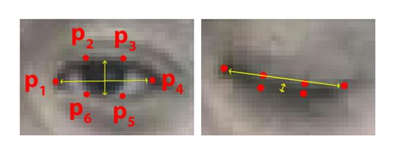

Figure 7: Eye Aspect Ratio

Finally, we determine the eyes state, the decision is made based on the EAR calculated. If the EAR is lower than the threshold, then the Eyes state is classified as “closed” otherwise “open”.

In the final step we assess if the driver is drowsy or not; for this we have a pre-set condition/ standard for sleepiness. The average blink duration of a person is 100-400 milliseconds. We have set a

time frame of 15 seconds. If the eyes remain closed for 15 or more seconds, drowsiness is detected by the system, and it triggers the alarm and the warning sign on dashboard.

* 1. **Libraries Used**
* Dlib
* OpenCV
* Imutils
* Pygame
* Numpy
  1. **Configuration**

The language that will be used to construct this project is Python. Python is an interpreted, high-level programming language. The data science industry has many experts who are proficient in this language. Python offers an extensive collection of libraries that help developers work with machine learning more efficiently.

Machine used details = Intel i5 processor.

RAM = 8GB

OS = Windows 10/11

Language = Python 3.11

Text Editor = Jupyter Notebook/ VS Code

**CHAPTER-5**

**IMPLEMENTATION**

**Step 1**: We will take images as input from the camera. Which will be placed on the car dashboard.

Figure 8: Capturing the image through CV2

**Step 2:** We willdetect face from the Image and create a Region of Interest (ROI) to detect the eyes in the image, we convert the image into grayscale as OpenCV algorithm takes gray images as the input, then use Haar cascade classifier to detect face at last in that image, we have to detect the eyes Landmarks and that will give us the ROI.

Figure 9: Detected the ROI.

**Step 3:** If the EAR is less than threshold for 20 frames the driver is alerted using the alarm.

Figure 10: Eyes are closed and showing alert.

**CHAPTER-6**

**RESULT/TESTING OF PROJECT**

Figure 11: Capturing the image. Figure 12: Straight face, Bad light, no glasses.

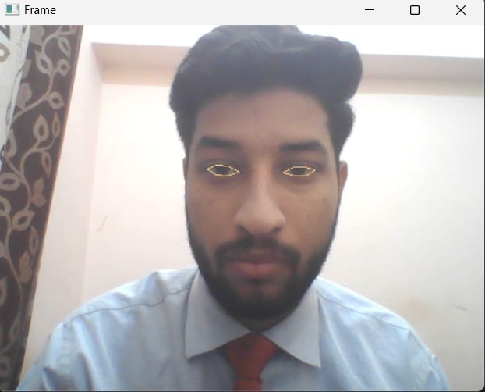 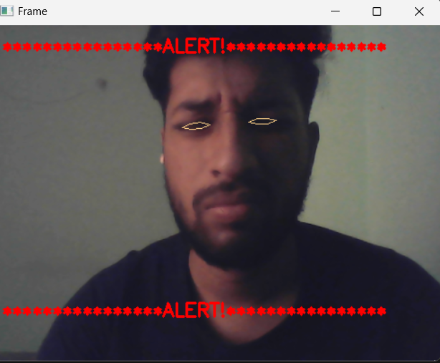

Figure 13: Straight face, good light, no glasses. Figure 14: Straight face, Bad light, no glasses.

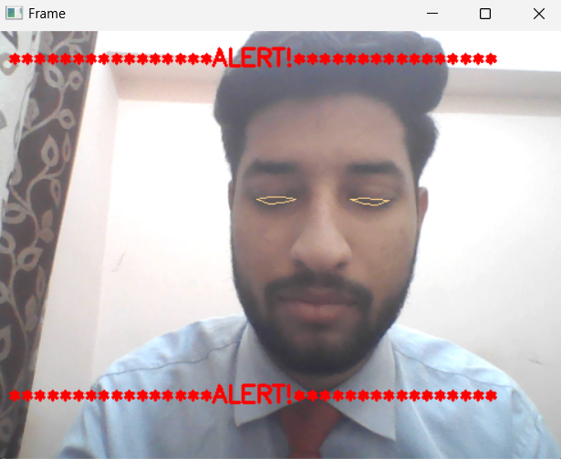 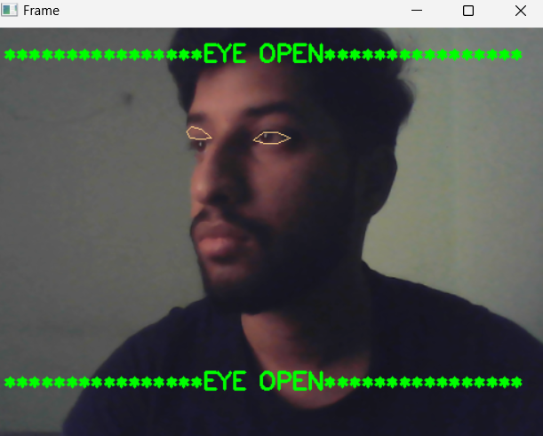

Figure 15: Straight face, good light, no glasses Figure 16: Tilted face, Bad light, no glasses.

Figure 17: Tilted face, Bad light, no glasses. Figure 18: Tilted face, good light, no glasses.

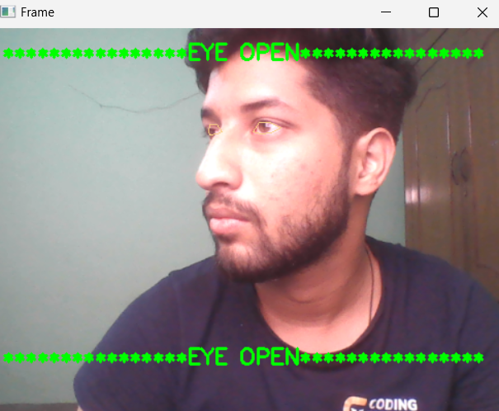

Figure 19: Tilted face , Good Light, no glasses.

The Six test cases for driver drowsiness detection that were done as part of this research are represented in the following table.

Table 1: System Testing

|  |  |  |  |  |
| --- | --- | --- | --- | --- |
| **Test Cases** | **Test Condition** | **Eye Spotted** | **Eye Close Spotted** | **Results** |
| Test 1 | Straight face, good light, no glasses | No | No | No Alarm |
| Test 2 | Straight face, good light, no glasses | Yes | No | No Alarm |
| Test 3 | Straight face, good light, no glasses | Yes | Yes | Alarm Sound |
| Test 4 | Straight face, Bad light, no glasses | Yes | Yes | Alarm Sound |
| Test 5 | Tilted face, good light, no glasses | Yes | No | No Alarm |
| Test 6 | Straight face, Bad light, no glasses | Yes | No | No Alarm |

**CHAPTER-7**

**CONCLUSION AND FUTURE SCOPE**

Conclusion:

In conclusion, creating a system for real-time driver drowsiness detection that uses eye detection methods has the potential to dramatically increase road safety and prevent accidents brought on by driver fatigue and drowsiness. The suggested system monitors the driver's facial features, such as eye movement, blink rate movement, to identify tiny changes in the driver's behavior that indicate drowsiness. The suggested system computes the ocular aspect ratio from video data collected by a camera positioned on the car's dashboard to identify indicators of sleepiness (EAR). In this study, we proposed an EAR [2], dlib, and SVM-based driver drowsiness detection system [15]. In terms of detecting driver fatigue with high accuracy and an F1 score, the system displayed encouraging findings. The suggested technique can be utilized to stop accidents brought on by drowsy driving in the real world. The device warns the driver and the vehicle's control system in real time via visual and audio cues when the driver's sleepiness levels reach a set threshold, allowing the driver to take the required precautions to prevent accidents. Large datasets of actual driving situations were used to assess the effectiveness of the suggested system, and the findings indicate that the system is extremely accurate and dependable at spotting driver intoxication.

To sum up, the suggested driver drowsiness detection system in this research study that combines EAR, dlib, and SVM has proven to be successful in identifying driver tiredness with high accuracy and F1 score. There are three primary components to the system: face identification and tracking, eye region extraction and EAR computation, and SVM-based categorization [15]. The suggested technique can be employed in real-world situations to stop accidents brought on by drowsy driving. However, further research can be conducted to improve the system's accuracy and efficiency, such as combining unique features, using different classifiers [12], or exploring deep learning techniques [14].

Future Scope:

1. The same model and methods can be applied to a variety of other applications, such as allowing Netflix and other streaming services to recognize when a user is dozing off and stop the video accordingly.
2. Our model is designed for detection of drowsy state of eye and give and alert signal or warning in the form of audio alarm. But the response of the driver after being warned may not be enough to stop causing the accident meaning that if the driver is slow in responding towards the warning signal, then accident may occur. Hence to avoid this we can design and fit a motor driven system and synchronize it with the warning signal so that the vehicle will slow down after getting the warning signal automatically.
3. Integration with wearable devices the use of advanced machine learning algorithms, such as deep learning, can further enhance the accuracy of the drowsiness detection system by learning from previous data and making predictions based on it.

**APENDIX**

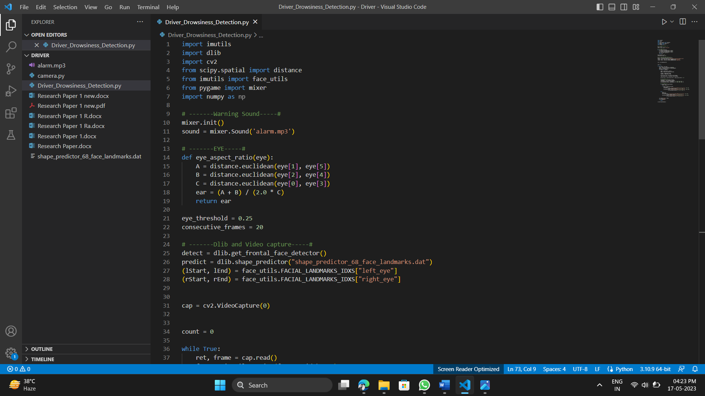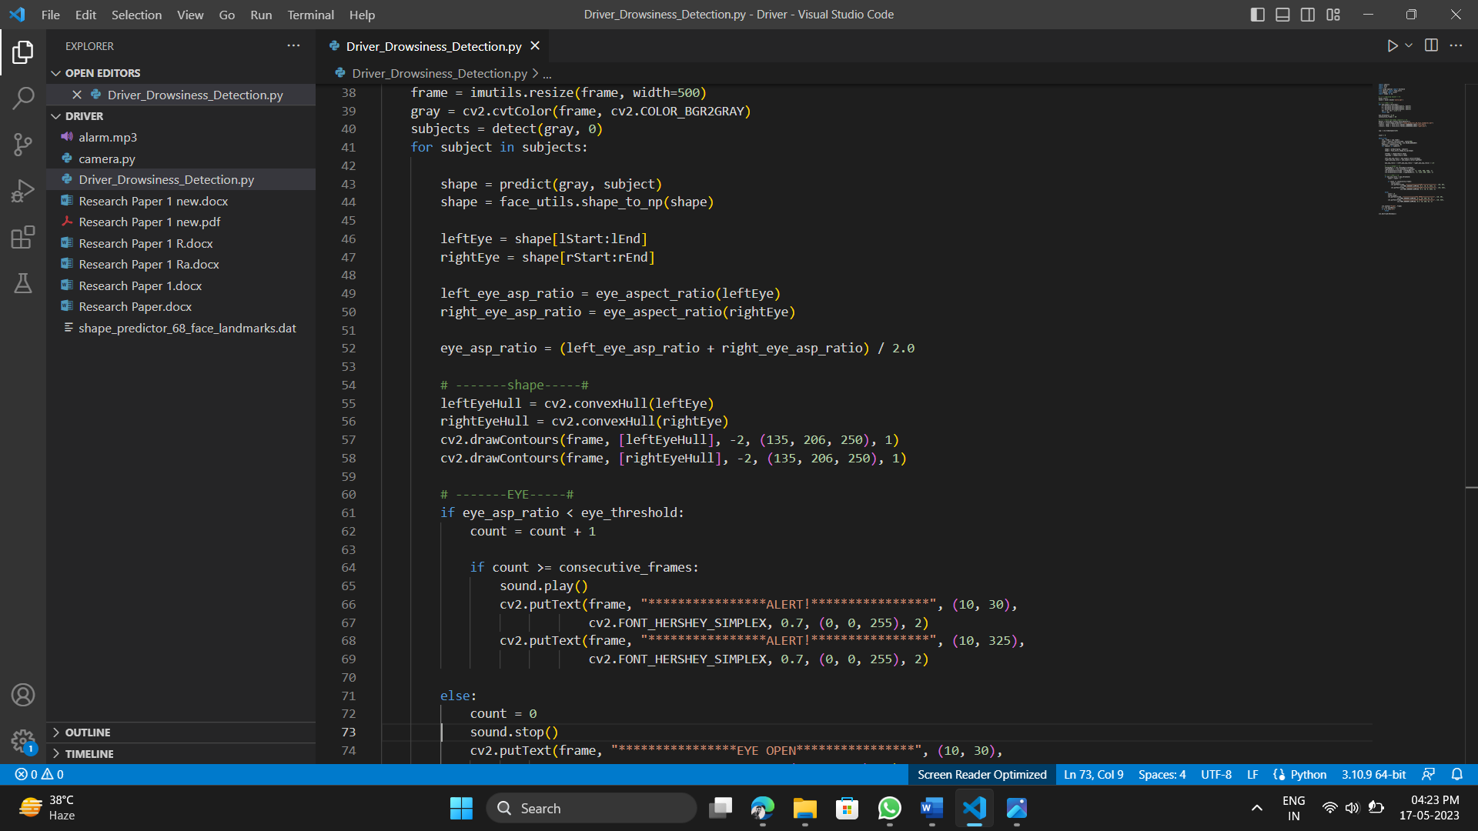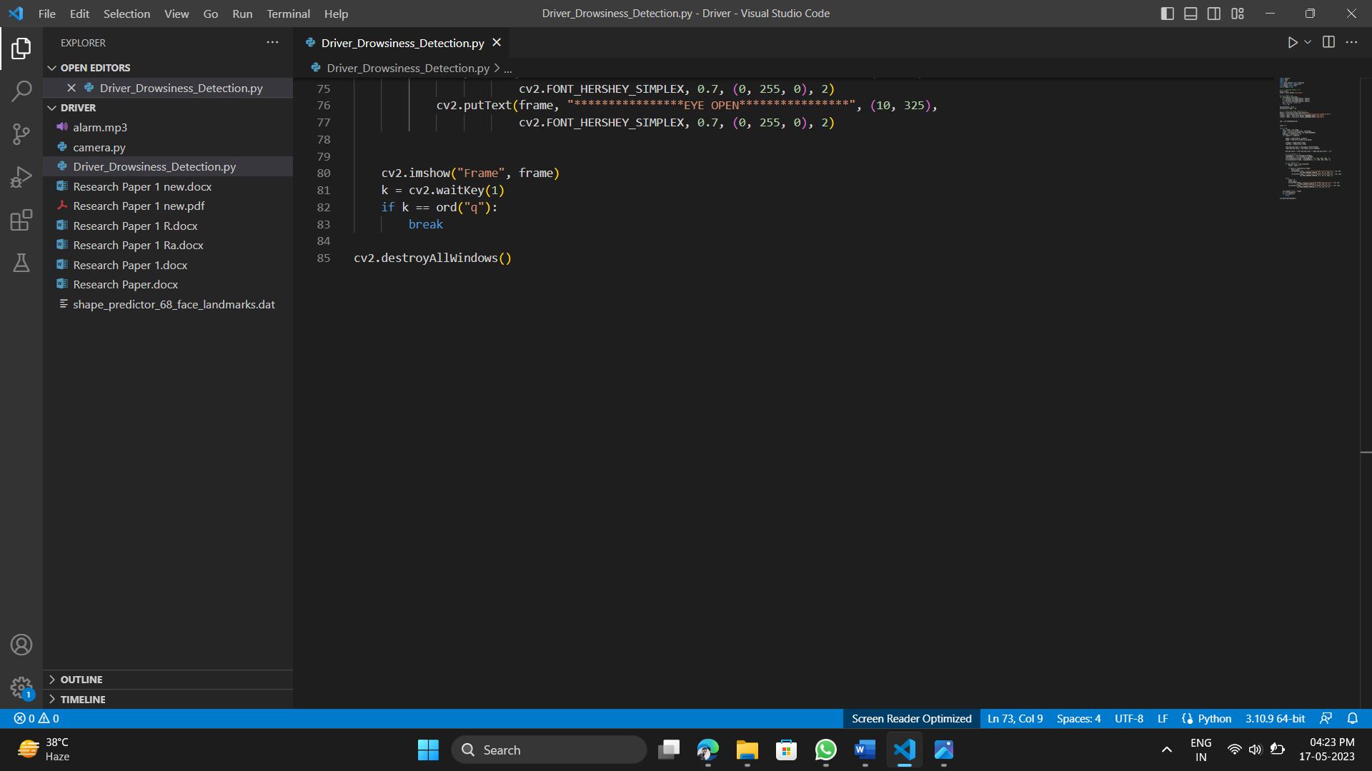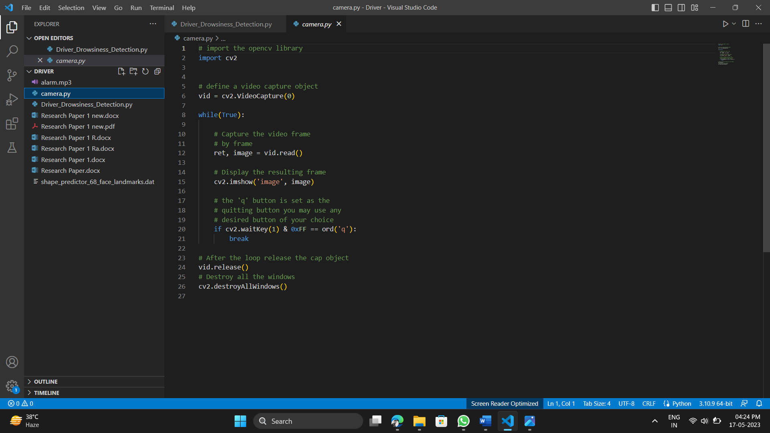

**REFERENCES**

[1] “Real-time driver drowsiness detection system using facial landmarks” by J. Kim et al. (2020)

[2] Aditya Ranjan, Karan Vyas, Sujay Ghadge, Siddharth Patel, Suvarna Sanjay Pawar, “Driver Drowsiness Detection System Using Computer Vision.,” in International Research Journal of Engineering and Technology (IRJET), 2020.

[3] B.Mohana, C.M.Sheela Rani, “Drowsiness Detection Based on Eye Closure and Yawning Detection,” in International Research Journal of Engineering and Technology (IRJET), 2019 .

[4] "Driver Drowsiness Detection by Applying Deep Learning Techniques to Sequences of Images" by Elena Magán, M. Paz Sesmero, Juan Manuel Alonso-Weber, and Araceli Sanchis, Computer Science and Engineering Department, Universidad Carlos III de Madrid, 28911 Leganés, Spain – 2022.

[5] “An Adaptive Driver Drowsiness Detection System using Eye Tracking and EEG Signals” by M. A. Adel et al. (2018).

[6] “Joint face detection and alignment using multitask cascaded convolutional networks”, K. Zhang, Z. Zhang, Z. Li, and Y. Qiao, IEEE Signal Processing Letters, vol. 23, no. 10, pp. 1499-1503, Oct. 2016.

[7] F. J. Henriques, R. Caseiro, P. Martins and J. Batista, “Exploiting the circulant structure of tracking-by-detection with kernels”, Proceedings of the European Conference Computer Vision, pp. 702-715, 2012.

[8] S. Abtahi, B. Hariri and S. Shirmohammadi, “Driver drowsiness monitoring based on yawning detection”, Proceedings of the IEEE International Control, Measurement, and Instrumentation (CMI), IEEE, pp. 1-4, May 2011.

[9] T. Danisman, I.M. Bilasco, C. Djeraba and N. Ihaddadene, “Drowsy driver detection system using eye blink patterns,” Universite Lille 1 & Telecom Lille 1, Marconi, France, 2010.

[10] Information about the driver fatigue vision system developed by the PSA in

cooperation with the Technical University of Lausanne – 2017.

[11] B.A. Efraty, M. Papadakis, A. Proﬁtt, S. Shah and I.A. Kakadiaris “Facial component landmark detection” – ieee explore 2011.

[12] “Face detection using haar cascade classifier” by Bhavana R. Maale , Dr. Suvarna Nandyal- 2021.

[13] “Real-Time Eye Blink Detection using Facial Landmarks” Tereza Soukupova and Jan ´ Cech, Center for Machine Perception, Department of Cybernetics Faculty of Electrical Engineering, Czech Technical University in Prague.

[14] F. N. Iandola, S. Han, M. W. Moskewicz, K. Ashraf, W. J. Dally, and K. Keutzer, "Squeezenet: Alexnet-level accuracy with 50x fewer parameters and <0.5Mb model size", Proceedings of the International Conference of Learning Representations, pp. 1-13, 2017.

[15] “Real Time Driver Fatigue Detection Based on SVM Algorithm” by Burcu Kır Savaş, Yaşar Becerikli -2018.

[16] Bergasa, L.; Nuevo, J.; Sotelo, M.A.; Barea, R.; Guillén, M. Real-time system for monitoring driver vigilance. IEEE Trans. Intell. Transp. Syst. 2006.

[17] Lorente, M.P.S.; Lopez, E.M.; Florez, L.A.; Espino, A.L.; Martínez, J.A.I.; de Mi-guel, A.S. Explaining Deep Learning-Based Driver Models. Appl. Sci. 2021.

[18] Dinges, D.F. An overview of sleepiness and accidents. J. Sleep Res. 1995.

[19] “Real-Time Driver-Drowsiness Detection System Using Facial Features” by Wanghua Deng, Ruoxue Wu (2019).

[20] “Real-Time Driver Drowsiness Detection using Computer Vision” by Mahek Jain, Bhavya Bhagerathi, Sowmyarani C N (2021).

[21] “Driver Drowsiness Detection by Applying Deep Learning Techniques to Sequences of Images” by Araceli Sanchis de Miguel, Elena Magán López, M. Paz Sesmero Lorente (2022).

[22] “Real Time Driver Fatigue Detection Based on SVM Algorithm” by Burcu Kır Savaş, Yaşar Beefily (2018).

[23] “A Deep Learning Approach to Detect Driver Drowsiness” by Madhav Tibrewal , Aayush Srivastava , Dr. R. Kayalvizhi (2021).

[24] “Driver Drowsiness Detection System” by Varad Ingale , Varun Gujarathi , Vasundhara Iyer, Varun Patil , Atharv Vanjari, Yogeshwari Rathod (2021).

[25] “Driver Drowsiness Detection using Microservices and Convolutional Neural Network” by Shrut Shah (2020).

[26] “DRIVER DROWSINESS DETECTION” by Harshit Verma, Amit Kumar, Gouri Shankar Mishra, Ujjwal deep, Pradeep Kumar Mishra, Parma Nand (2023).

[27] “Deep learning neural network for driver drowsiness detection using eyes recognition” by Mustafa Kamel Gatea, Sadik Kamel Gharghan, Adnan Hussein Ali (2023).

[28] “Drowsiness Detection Mobile Vision Face API” by G Mahalakshmi , Sharan Kumar S , Kishok Kumar M , Gokul M, Balamurali S (2022).